## Report No.6: System User’s Manual

##### 6.1. Installation Guide

6.1.1 System requirements

* Operation system: Windows 7 (32 or 64 bit) or laster
* Memory: 2G RAM or more
* Browser: Firefox v25 or laster
* IIS feature is turned on

6.1.2 Installation

6.1.2.1 Deploy Database

* Run script file “~/FootballPitchesBooking/Database/FootballPitchesBooking.sql” in SQL Server Management Studio.

6.1.2.2 Deploy Application

* Open “Internet information Services (IIS) Manager”.
* Right click on “Sites” folder in left content, select “Add Web Site”.

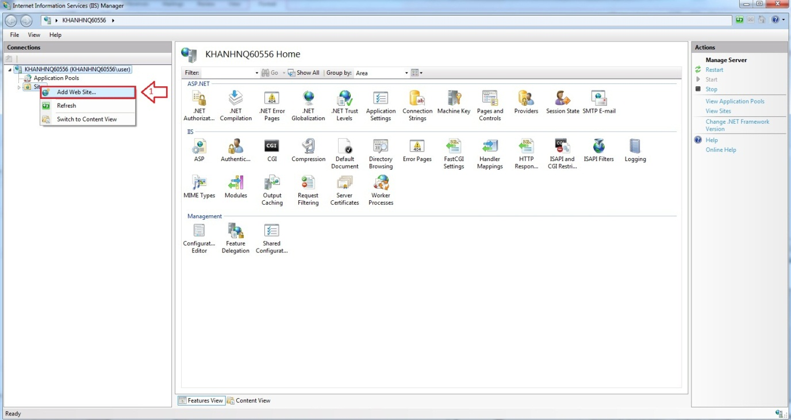

* Enter “Site Name”.
* Click on “Select” button to select Application pool.

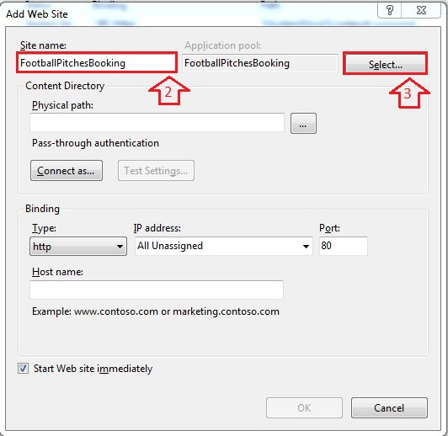

* Select “ASP.NET v4.0”.

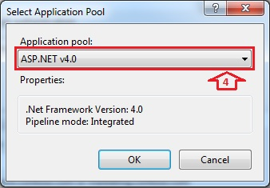

* Browse physical path: “~/ FootballPitchesBooking”.

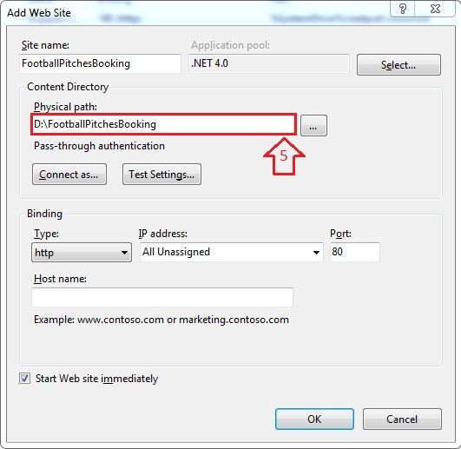

* Open “~/ FootballPitchesBookingProject/Web.config” file by Notepad.

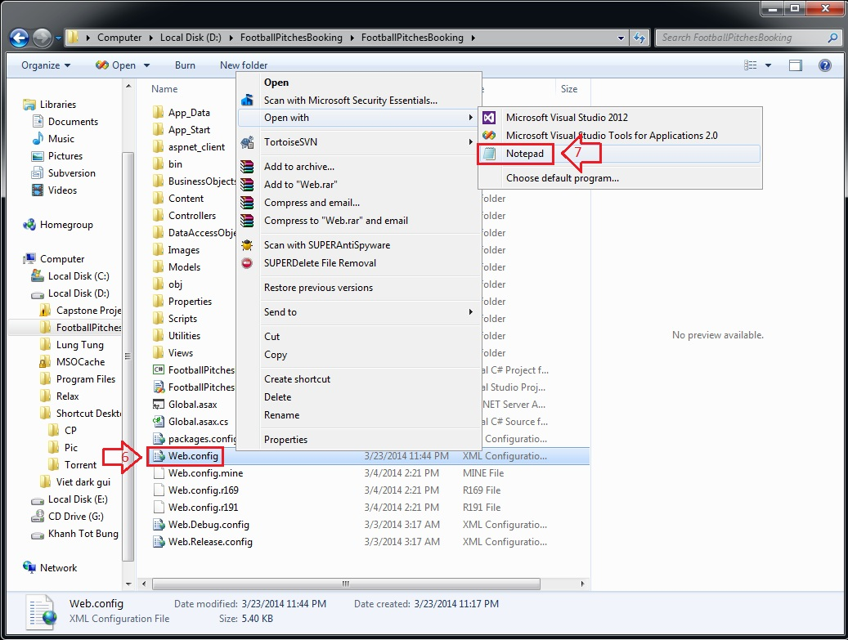

* Find “connectionStrings” tag, change “Server Name”, “User ID” and “Password” in its connection string depend on your computer.

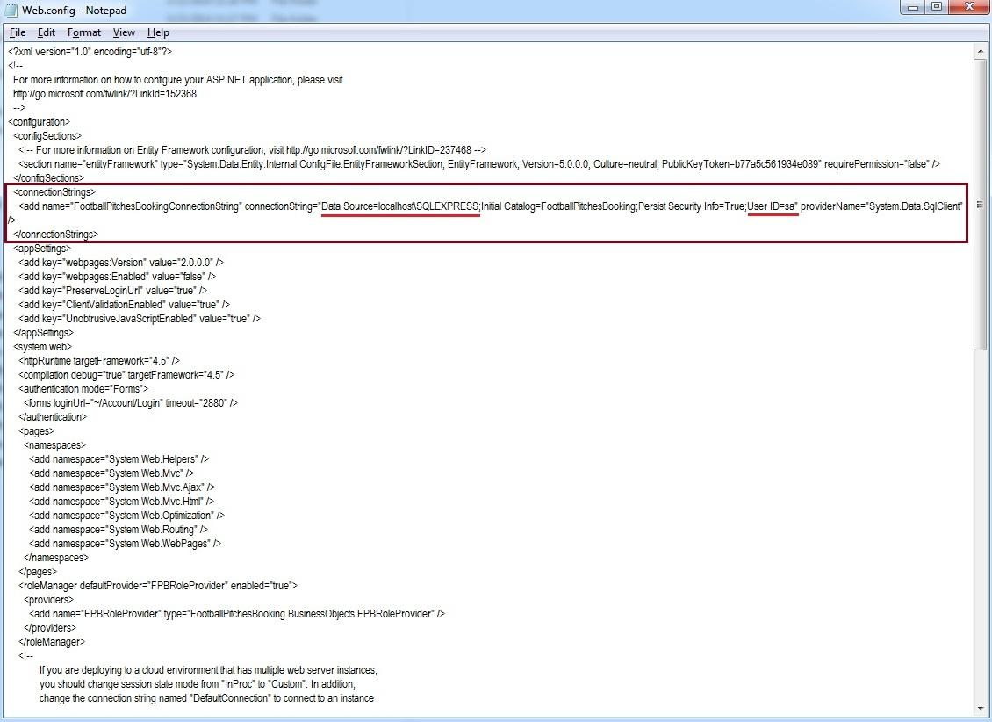

* Right click on new site name (FootballPitchesBooking) in left content -> Manage Web Site -> Browse to view the website.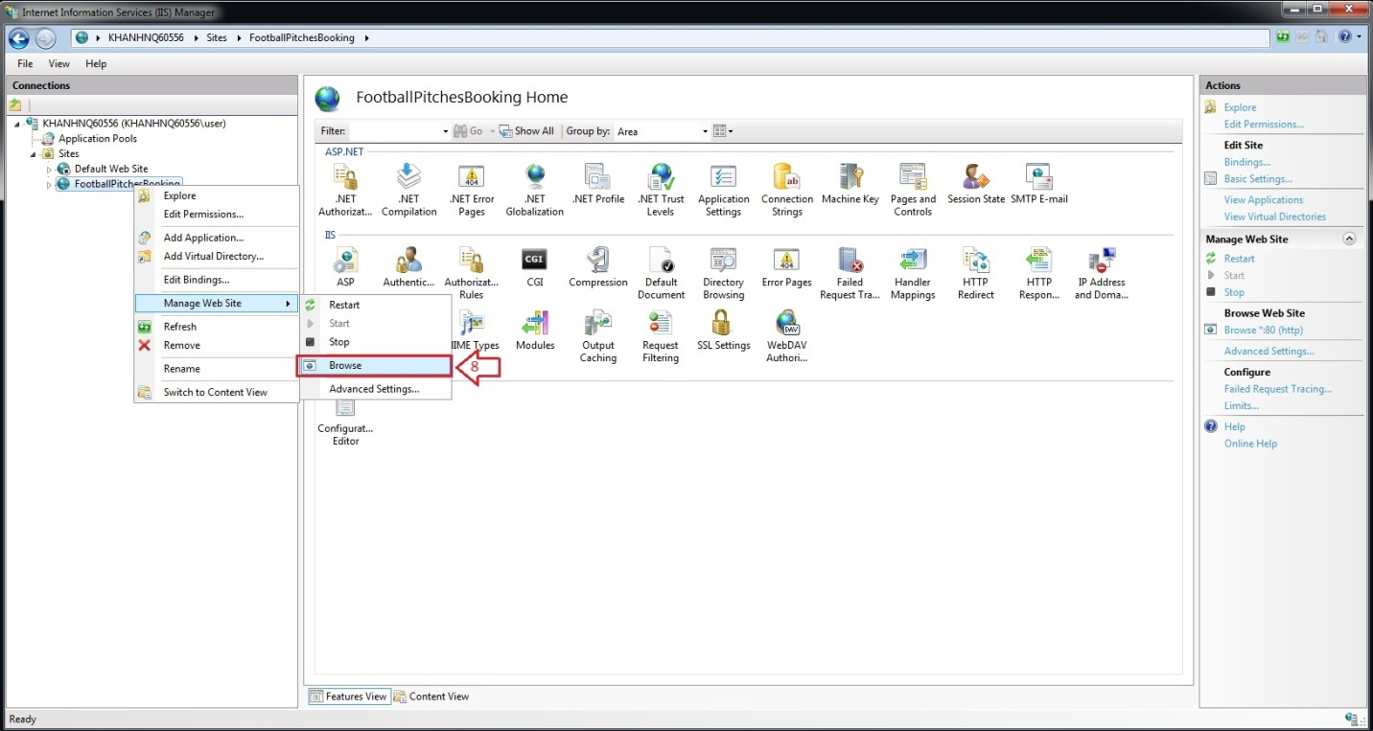
* The website is deployed.

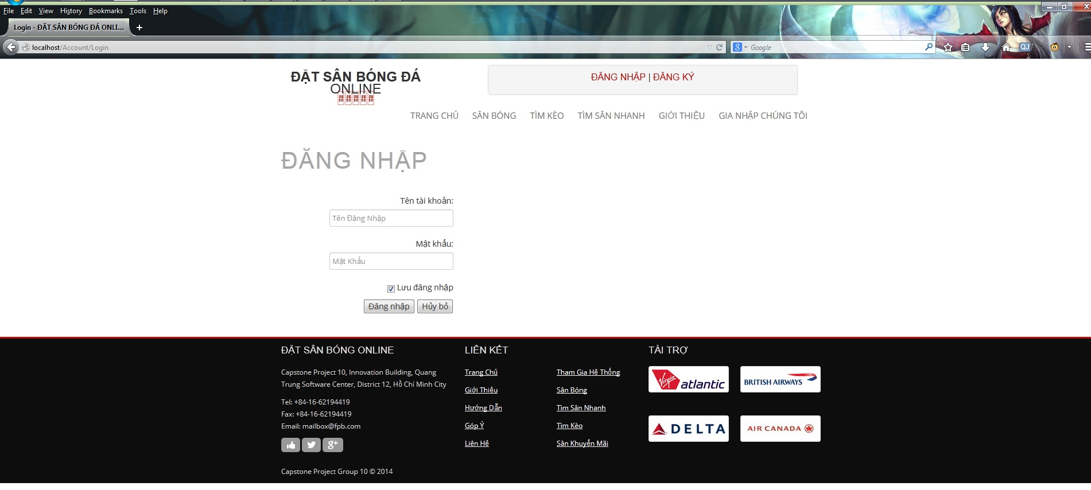

##### 6.2. User’s Guide

6.2.1. Website Staff

6.2.1.1. Join Request Management

6.2.1.2. Stadium Management

6.2.1.3. User Management

6.2.1.3.1 View List Members

- Step 1: Click “Quản Trị Website” link in Admin page

- Step 2: Choose “ Thành Viên “ link to view all members of the website

6.2.1.3.2 Search Members

- Step 1 : Click textbox beside Search Button in “ Quản Lý Người Sử Dụng “ page

- Step 2 : Input name of member you want to find

- Step 3 : Click “ Tìm Kiếm “ button to find

- Step 4 : Click “ Làm Mới “ to refresh member list.

6.2.1.3.3 Edit Members

- Step 1 : Click on name of the member you want to change information

- Step 2 : Change information which field you want to change result

- Step 3 : Click “ Cập Nhật” button to save the information of member or click “Huỷ bỏ” button to cancel

6.2.1.4. Advertise Management

6.2.1.5. Member Rank Management

6.2.1.5.1 View List Ranks

- Step 1: Click “Quản Trị Website” link in Admin page

- Step 2: Choose “ Hệ Thống Cấp Bậc “ link to view memberrank of the website

6.2.1.5.2 Add Rank

- Step 1 : Click “ Thêm Thứ Hạng “ link in “ Hệ Thống Cấp Bậc “ page

- Step 2: Input in all required field

- Step 3: Click “ Lưu” button to add memberrank or click “Huỷ bỏ” button to cancel

6.2.1.5.3 Edit Rank

- Step 1 : Click “ Sửa “ link in each of memberrank in “ Hệ Thống Cấp Bậc “ page

- Step 2 : Change information which field you want to change result

- - Step 3: Click “ Lưu” button to save the memberrank or click “Huỷ bỏ” button to cancel

6.2.2. Stadium Staff

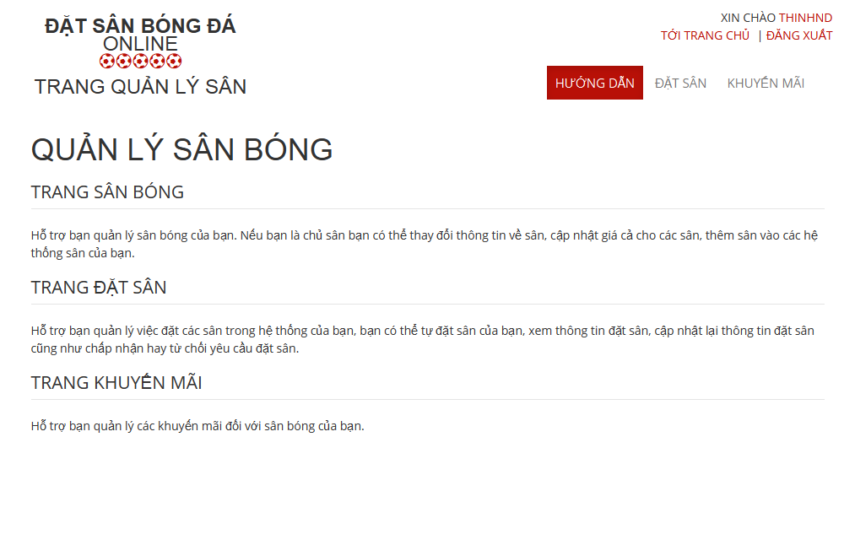

6.2.2.1 Stadium Management

6.2.2.2 Field Management

6.2.2.3 Promotion Management

6.2.2.3.1. View List Promotions

- Step 1: Click “Khuyến mãi” link in Stadium Management page

- Step 2: Choose Stadium to view promotions of that stadium

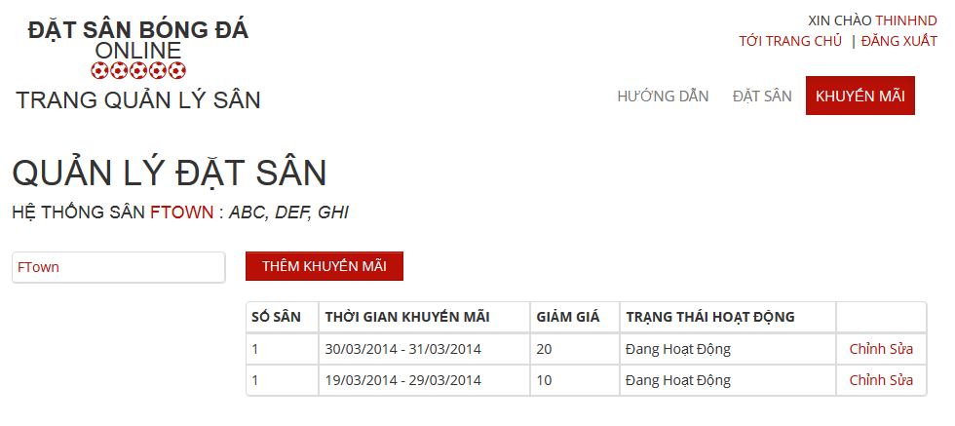

6.2.2.3.2. Add New Promotion

- Step 1: Click “Thêm khuyến mãi” button from Promotion Management page

- Step 2: Input information about promotion

- Step 3: Click “Lưu” button to save or click “Huỷ bỏ” to cancel

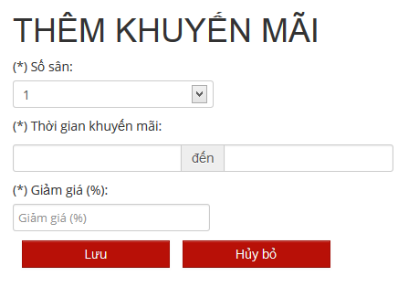

6.2.2.3.3. Edit Promotion

- Step 1: Click “Chỉnh sửa” link on what promotion you wanna edit

- Step 2: Change information about that promotion

- Step 3: Click “Lưu” button to save or click “Huỷ bỏ” to cancel

6.2.2.4 Reservation Management

6.2.3. User

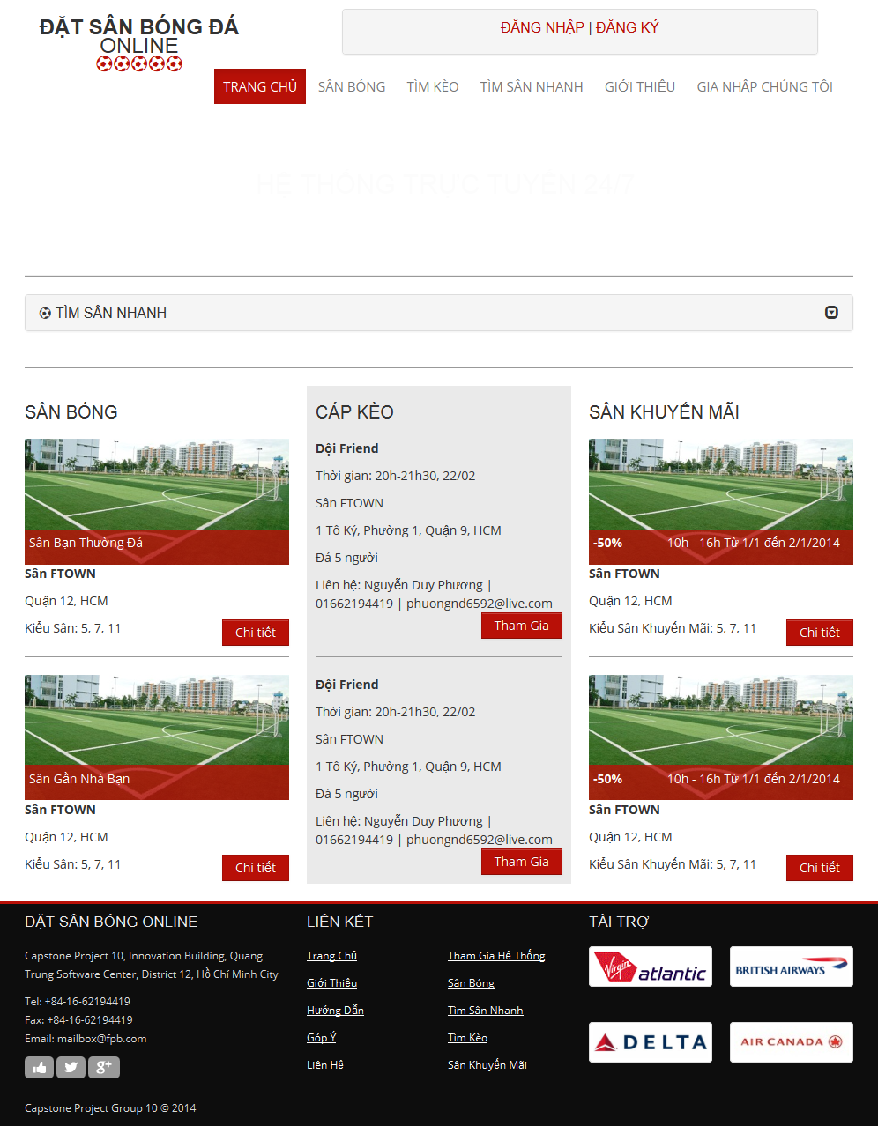

6.2.3.1. Register

- Step 1: Click “Đăng ký” link on home page.

- Step 2: Input all required field

- Step 3: Click “Đăng ký” button to register, or click “Huỷ bỏ” button to cancel

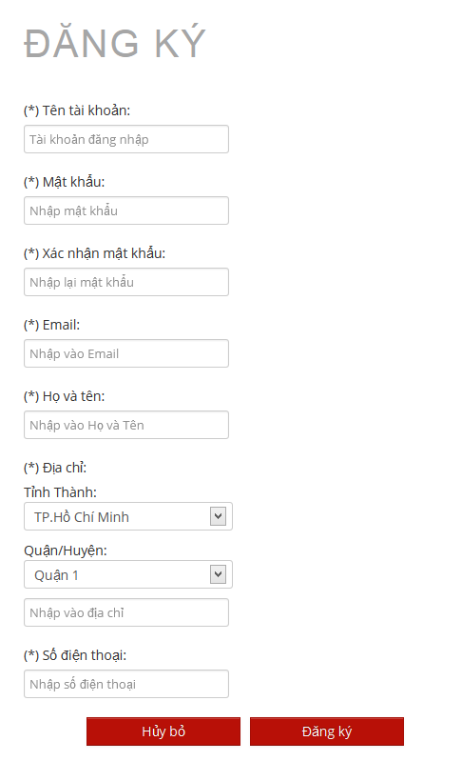

6.2.3.2. Login

- Step 1: Click “Đăng nhập” link on home page

- Step 2: Input username and password

- Step 3: Click “Đăng nhập” button

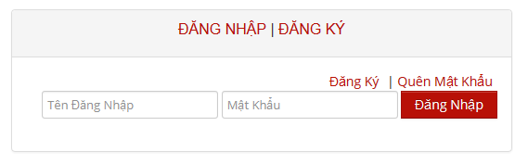

6.2.3.3. View Account Profiles

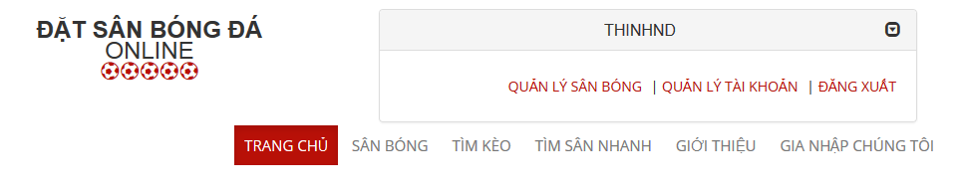

* Step 1: Click username link to open management window
* Step 2: Click “Quản lý tài khoản” link

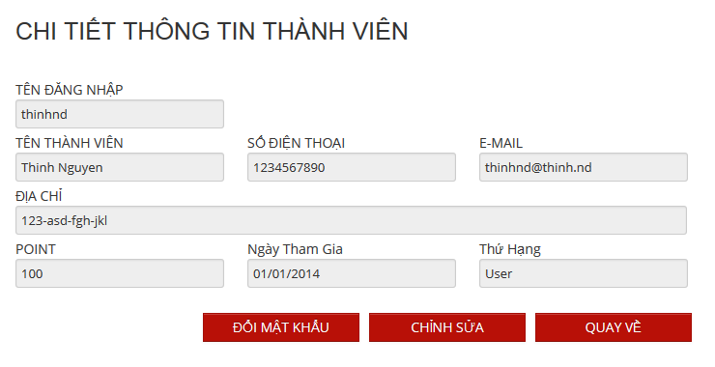

6.2.3.4. Edit Account Profiles

Edit Account Profiles

- Step 1: Click “Chỉnh sửa” button from view account profiles page

- Step 2: Change account profiles information

- Step 3: Click “Lưu” to save or click “Quay về” to cancel and back to view account profiles page

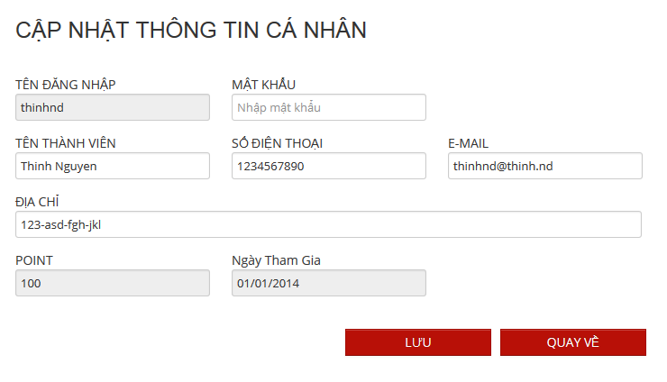

Change Password:

* Step 1: Click “Đổi mật khẩu” button from view account profiles page
* Step 2: Input old and new password, confirm password
* Step 3: Click button “Lưu” to save new password or click “Quay về” button to cancel and back to view account profiles page

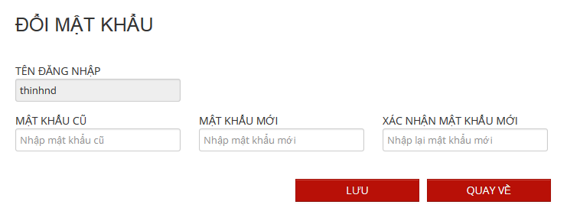

6.2.3.5. Find Available Stadium

- Step 1: Click “Tìm sân nhanh” link or open “Tìm sân nhanh” board at home page

- Step 2: Choose information

- Step 3: Click “Tìm kiếm” to find available stadium

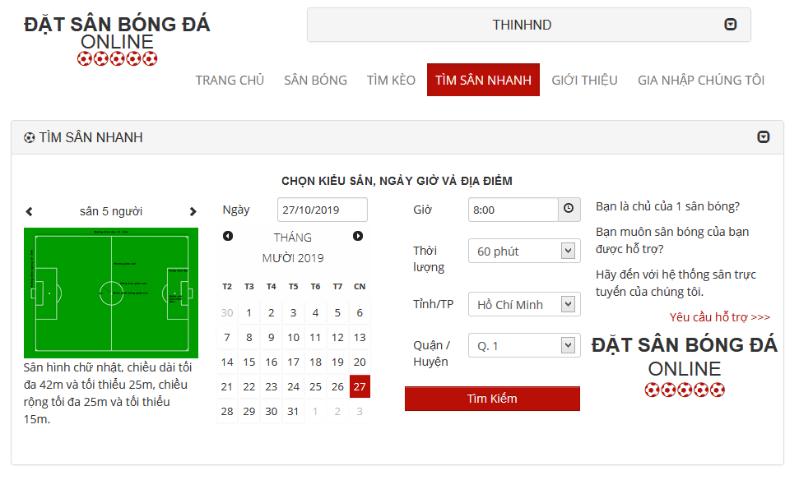

6.2.3.6. Find Stadium

- Step 1 : Click on “ Tìm Sân Nhanh “ link in Homepage

- Step 2 : Input all information about the stadium you want to find

- Step 3 : Click “ Tìm Kiếm “ button to find

6.2.3.7. View Stadium Details

6.2.3.8. Rating Stadium

- Step 1 : Click on “ Sân Bóng “ link in Homepage

- Step 2 : Click on the stadium you want to rate

- Step 3 : Click on 1 – 5 star for rating stadium

6.2.3.9. Review Stadium

- Step 1 : Click on “ Sân Bóng “ link in Homepage

- Step 2 : Click on the stadium you want to review information

6.2.3.10. Booking Pitches

6.2.3.11. Cancel Reservation

6.2.3.12. Find Rival

- Step 1 : Click on “ Tìm Kèo “ link in Homepage

- Step 2 : Click on team you want to fight or view information

- Step 3 : Clcik “ Xác Nhận “ button

6.2.3.13. Join Rival

6.2.3.14. View Booking History

_ Step 1: Click on “ Quản Lý Tài Khoản “ link   
- Step 2: Click on “Lịch Sử Đặt Sân “ to view booking history

6.2.3.15. Request Join System

- Step 1: Click “Gia nhập chúng tôi” link from home page

- Step 2: Input all require information

- Step 3: Click “Gửi yêu cầu” to send this request or click “Trang chủ” link to back to home page

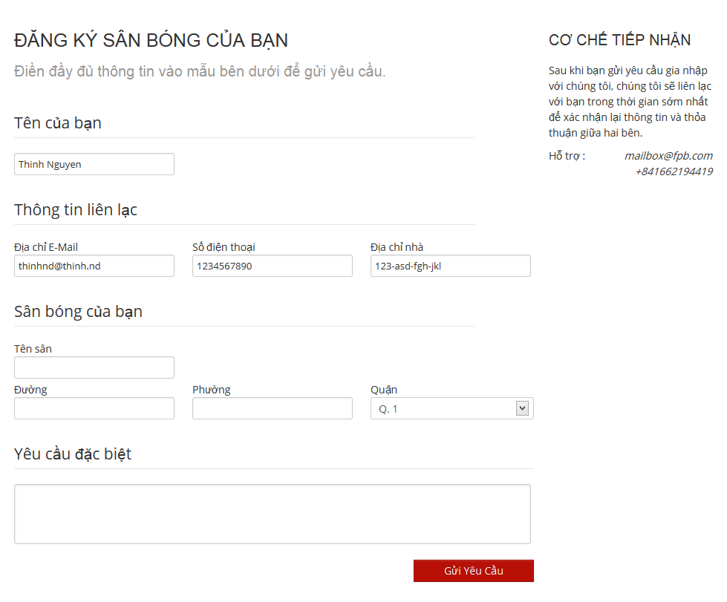

6.2.3.16. Feedback Website

##### 6.3. Other [Optional]